Subject: Important Information on Medicare for Your Upcoming 65th Birthday

Dear [Client's Name],
As your health insurance agent, I wanted to personally reach out to you as your 65th birthday is approaching. This is an important milestone as you'll soon be eligible for Medicare benefits. Your coverage will start on the first day of the month in which you turn 65. This email contains essential information about Medicare and the various options available to you, so please take the time to read through it carefully.

Signing up for Medicare:
You can sign up for Medicare during your Initial Enrollment Period, which begins three months before your 65th birthday, includes your birth month, and ends three months after your 65th birthday. You can enroll online at www.ssa.gov, over the phone at 1-800-772-1213, or by visiting your local Social Security office.

Medicare Part A and B:
Medicare Part A covers hospitalization, skilled nursing facility care, hospice care, and some home health services. For most people, there's no monthly premium for Part A, but there are deductibles and coinsurance.
Medicare Part B covers doctor visits, outpatient care, preventive services, and certain medical equipment. The standard Part B premium is $164.90 per month, with higher income earners paying more. There's also an annual deductible and 20% coinsurance for most services.
The total Medicare Part B premiums for high income beneficiaries for 2023 (based on 2021 income) are shown in the following table:
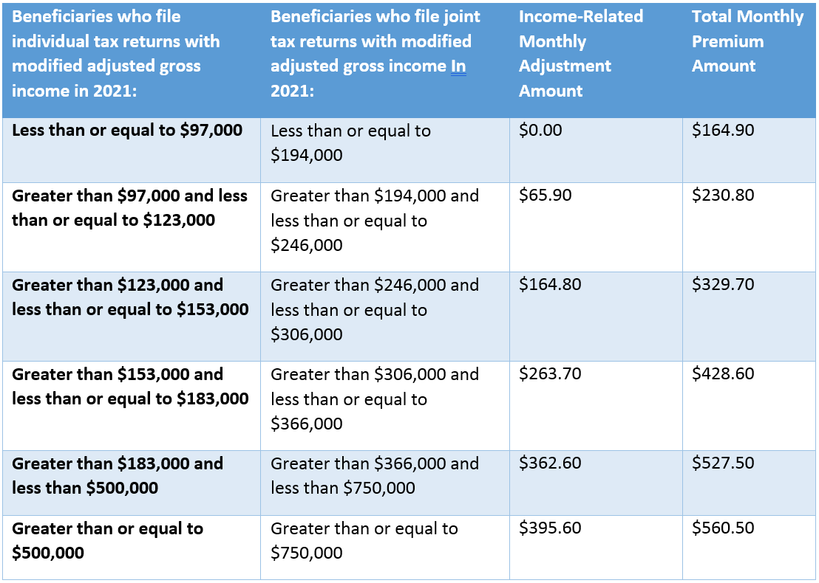

Holes or cost sharing in Medicare:
Although Medicare covers a wide range of healthcare services, there are some gaps in coverage, such as deductibles, coinsurance, and copayments. This is where additional insurance options, like Medicare Advantage (Part C) and Medicare Supplement (Medigap) plans, can be beneficial.

Option 1: Medicare Advantage (Part C) Plans:
Medicare Advantage plans are offered by private insurance companies and combine Part A and B coverage with additional benefits, such as vision, dental, and hearing care. Some plans also include prescription drug coverage (Part D). These plans often have lower out-of-pocket costs than Original Medicare and usually have a network of providers you must use. Premiums, deductibles, and copays vary based on the plan.

Option 2: Medicare Supplement (Medigap) Plans:
Medigap plans, also offered by private insurance companies, work alongside Original Medicare (Part A and B) to help cover out-of-pocket expenses such as deductibles, coinsurance, and copayments. Medigap plans don't include prescription drug coverage (Part D) or additional benefits like vision or dental. Premiums vary based on the plan and the level of coverage.

Medicare Part D:
Part D plans provide prescription drug coverage and are offered by private insurance companies. These plans can be added to Original Medicare or a Medigap plan but are usually included in Medicare Advantage plans. Premiums, deductibles, and copays vary based on the plan.
The chart below shows your estimated 2023 prescription drug plan monthly premium based on your income as reported on your IRS tax return from 2 years ago and last year. If your income is above a certain limit, you’ll pay an income-related monthly adjustment amount in addition to your plan premium.
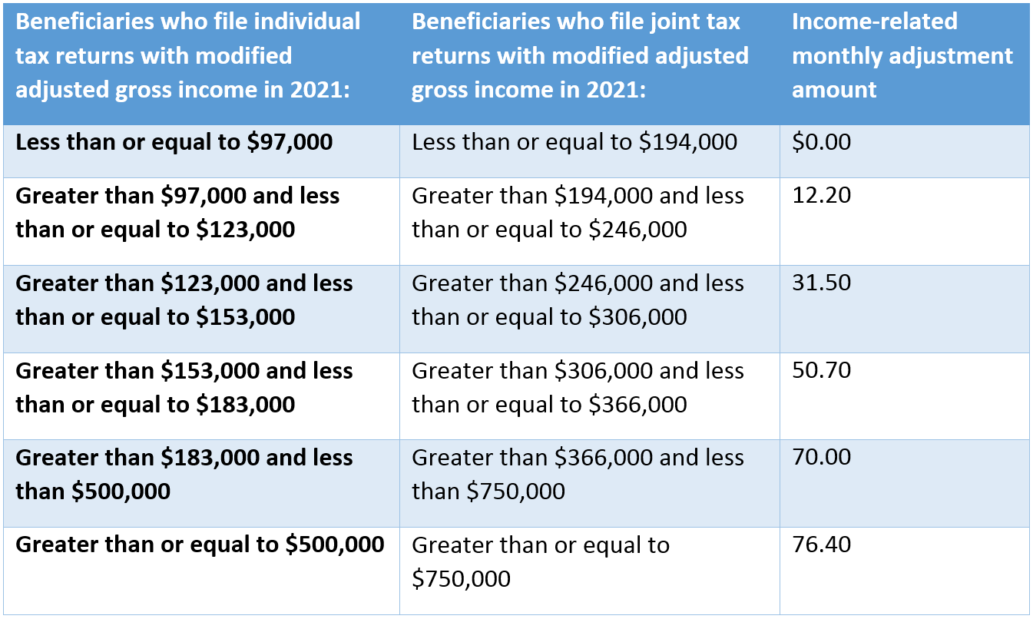

We understand this is a lot of information, but we want to ensure that you have a comprehensive understanding of your Medicare options. Our team is here to help you navigate this process and answer any questions you may have. Please don't hesitate to contact our office if you need further assistance or have any questions.

Sincerely,

